World History I Name
Mr. Louchheim Connections to Present Day

Chapter 13 section 2:

FEUDALISM

Directions: Please draw on our discussion on the different parts of the feudal system and the responsibilities each profession carries. Use this previous discussion to connect to today’s occupations , does the United States have a system of social classes? If so who would go where and why? Do you agree with the US hierarchy?

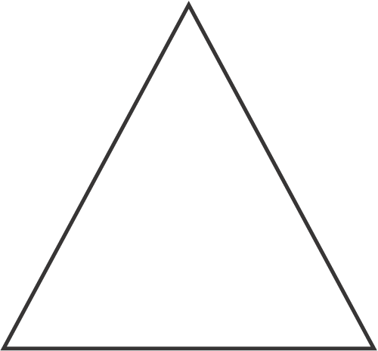

Possible occupations: Discuss with your group, circle one and explain why please.
Doctor- 1, 2, 3 or not sure
Why?

Retail store owner- 1, 2, 3 or not sure
Why?

Landlord- 1, 2, 3 or not sure
Why?

Plumber- 1, 2, 3 or not sure
Why?

Stock broker- 1, 2, 3 or not sure
Why?

Teacher- 1, 2, 3 or not sure
Why?

Actor/Actress- 1, 2, 3 or not sure
Why?

Waiter/Waitress- 1, 2, 3 or not sure
Why?

Taxi driver- 1, 2, 3 or not sure
Why?

Priest- 1, 2, 3 or not sure
Why?

Truck driver- 1, 2, 3 or not sure
Why?

Garbage collector- 1, 2, 3 or not sure
Why?

Nurse- 1, 2, 3 or not sure
Why?

Lawyer- 1, 2, 3 or not sure
Why?

Dentist- 1, 2, 3 or not sure
Why?

President of the United States- 1, 2, 3 or not sure
Why?

Governor of a state- 1, 2, 3 or not sure
Why?

President of a company- 1, 2, 3 or not sure
Why?

